Telling Time
# Source: AI Source: Provided by: [Data Path: Persons Table -> ID Column: 1, Name_En Column: Motasem Essam] -> From: [ChatGPT] on [7/17/2026]
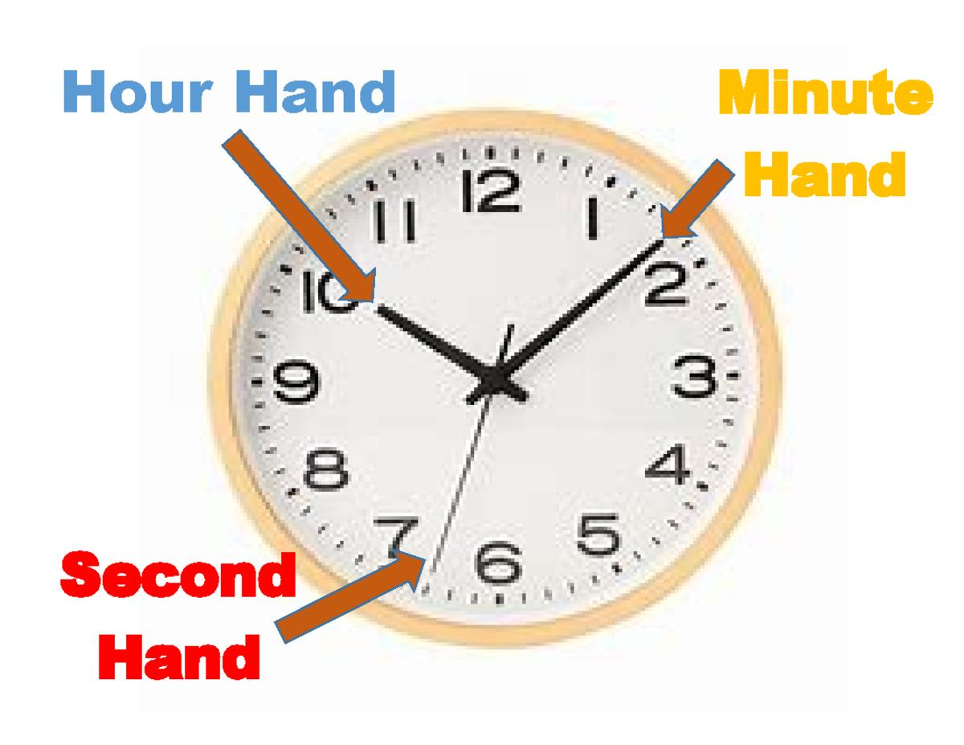
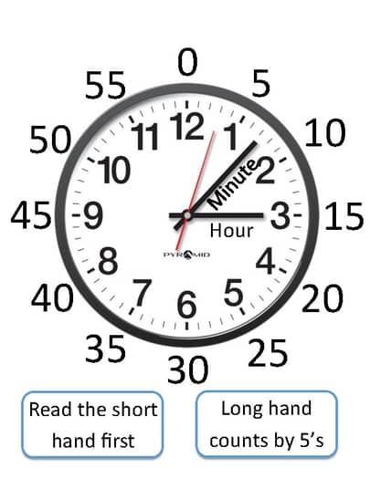
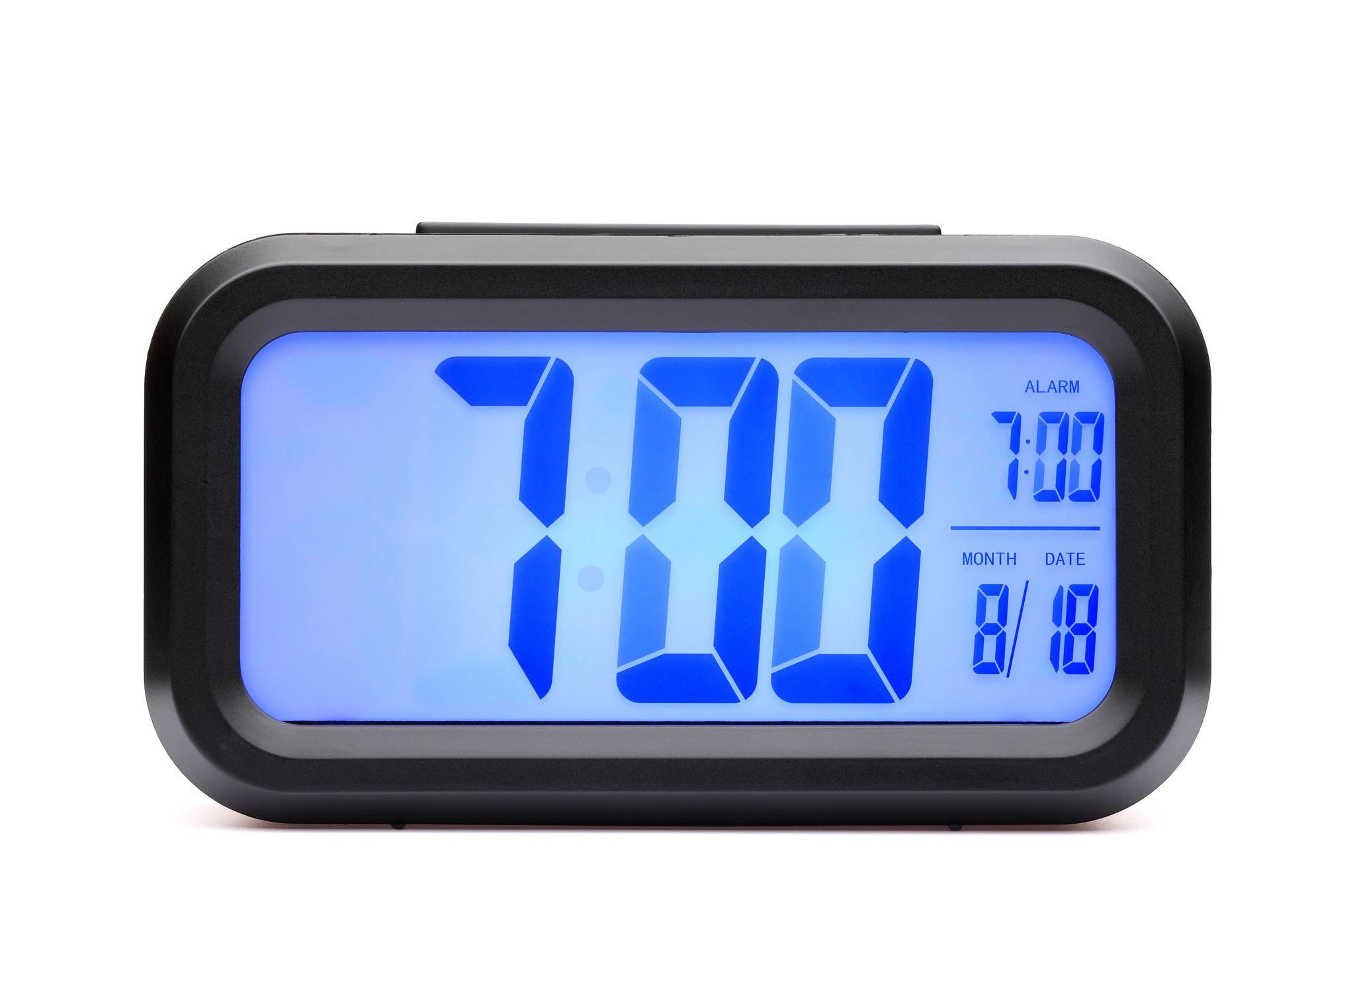
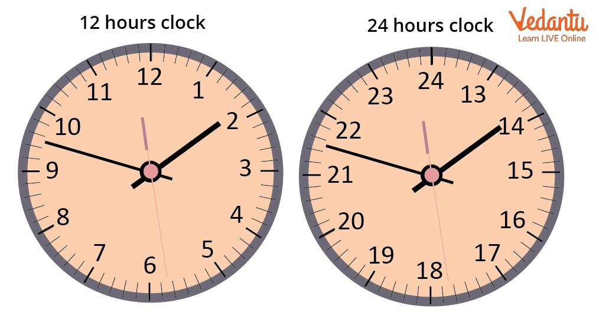
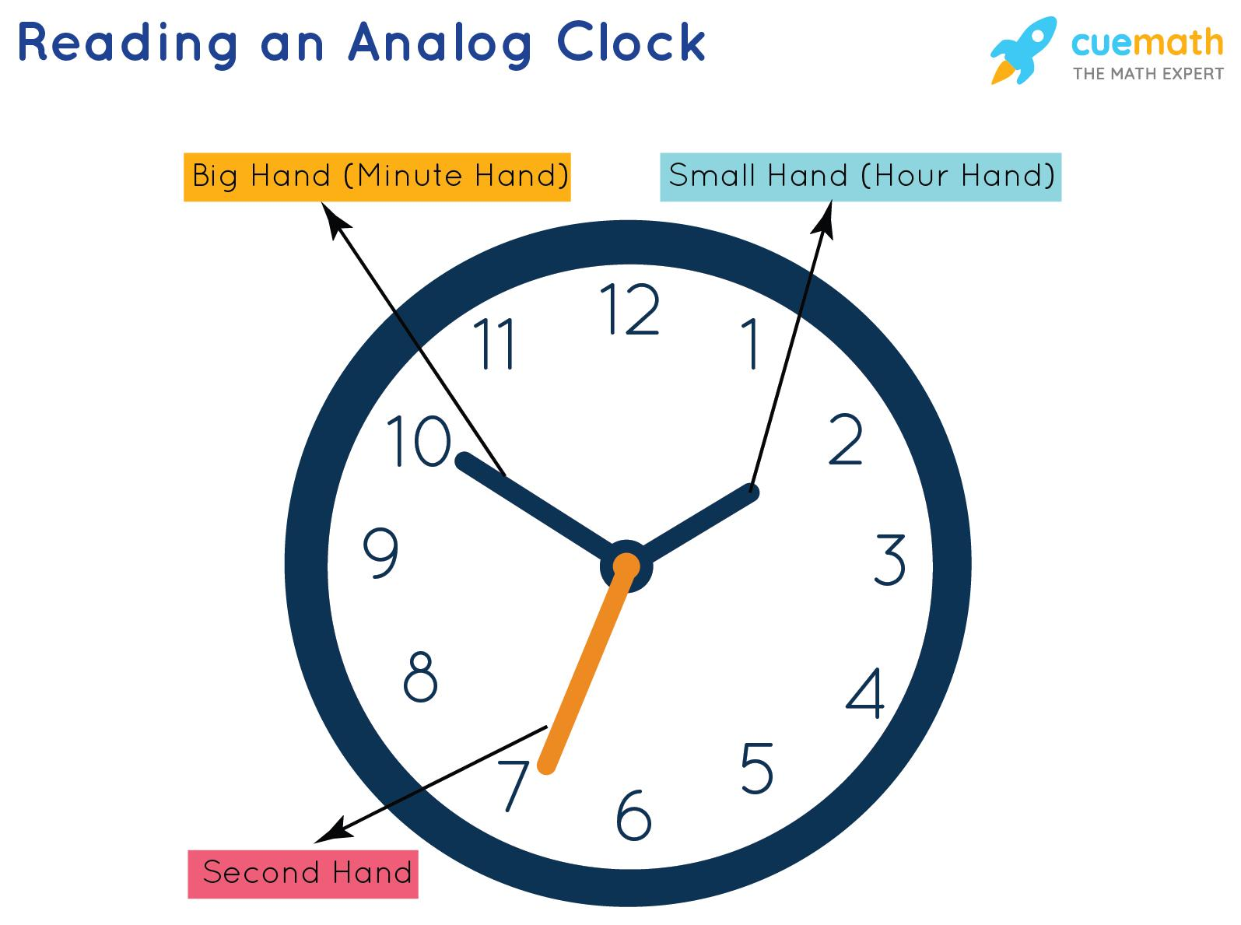
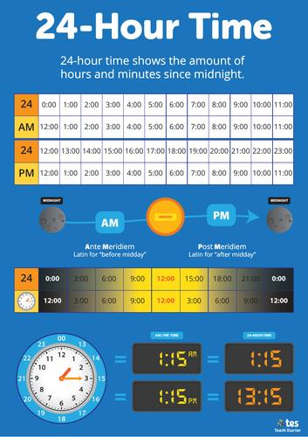
Telling Time is the process of reading and expressing the current time using clocks or watches. It allows people to determine when events happen, organize daily activities, and communicate specific moments during the day.
Time can be read using:
- Analog clocks
- Digital clocks
- 12-hour format
- 24-hour format

Definition
# Source: AI Source: Provided by: [Data Path: Persons Table -> ID Column: 1, Name_En Column: Motasem Essam] -> From: [ChatGPT] on [7/17/2026]
Telling Time is the skill of reading and interpreting clocks or watches to determine the current hour, minute, and sometimes seconds.

Parts of an Analog Clock
# Source: AI Source: Provided by: [Data Path: Persons Table -> ID Column: 1, Name_En Column: Motasem Essam] -> From: [ChatGPT] on [7/17/2026]
An analog clock has three main hands:
Hour Hand
- Shortest hand
- Indicates the hour
- Moves slowly around the clock
Minute Hand
- Longer hand
- Indicates the minutes
- Completes one full revolution every 60 minutes
Second Hand
- Longest and thinnest hand
- Indicates seconds
- Completes one full revolution every 60 seconds

Clock Face
# Source: AI Source: Provided by: [Data Path: Persons Table -> ID Column: 1, Name_En Column: Motasem Essam] -> From: [ChatGPT] on [7/17/2026]
A standard analog clock contains:
- 12 hour numbers
- 60 minute marks
Each number represents:
- 5 minutes
Example:
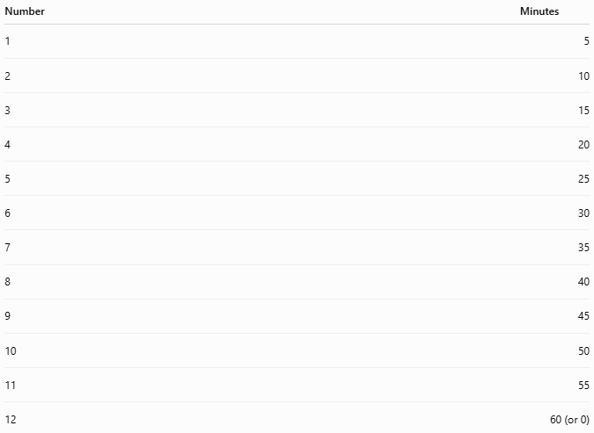
Number | Minutes
1 | 5
2 | 10
3 | 15
4 | 20
5 | 25
6 | 30
7 | 35
8 | 40
9 | 45
10 | 50
11 | 55
12 | 60 (or 0)

Reading an Analog Clock
# Source: AI Source: Provided by: [Data Path: Persons Table -> ID Column: 1, Name_En Column: Motasem Essam] -> From: [ChatGPT] on [7/17/2026]
Step 1
Read the hour hand.
It tells the current hour.

Step 2
Read the minute hand.
Each small mark equals:
- 1 minute
Each numbered position equals:
- 5 minutes

Step 3
Combine the hour and minute.
Example:
- Hour hand near 3
- Minute hand at 6
Time:
3:30

Reading a Digital Clock
# Source: AI Source: Provided by: [Data Path: Persons Table -> ID Column: 1, Name_En Column: Motasem Essam] -> From: [ChatGPT] on [7/17/2026]
Digital clocks display time directly.
Examples:
- 08:15
- 12:30
- 17:45
- 23:59

Time Formats
# Source: AI Source: Provided by: [Data Path: Persons Table -> ID Column: 1, Name_En Column: Motasem Essam] -> From: [ChatGPT] on [7/17/2026]
12-Hour Format
Uses:
- AM
- PM
Examples:
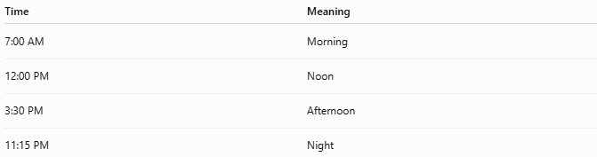
Time | Meaning
7:00 AM | Morning
12:00 PM | Noon
3:30 PM | Afternoon
11:15 PM | Night

24-Hour Format
# Source: AI Source: Provided by: [Data Path: Persons Table -> ID Column: 1, Name_En Column: Motasem Essam] -> From: [ChatGPT] on [7/17/2026]
Examples:
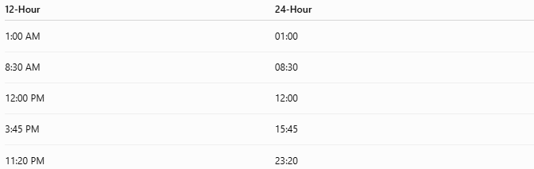
12-Hour | 24-Hour
1:00 AM | 01:00
8:30 AM | 08:30
12:00 PM | 12:00
3:45 PM | 15:45
11:20 PM | 23:20

Common Time Expressions
# Source: AI Source: Provided by: [Data Path: Persons Table -> ID Column: 1, Name_En Column: Motasem Essam] -> From: [ChatGPT] on [7/17/2026]
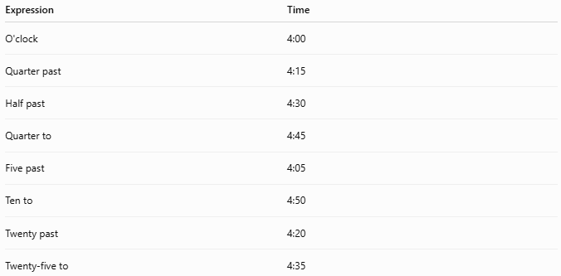
Expression | Time
O'clock | 4:00
Quarter past | 4:15
Half past | 4:30
Quarter to | 4:45
Five past | 4:05
Ten to | 4:50
Twenty past | 4:20
Twenty-five to | 4:35

Examples
# Source: AI Source: Provided by: [Data Path: Persons Table -> ID Column: 1, Name_En Column: Motasem Essam] -> From: [ChatGPT] on [7/17/2026]
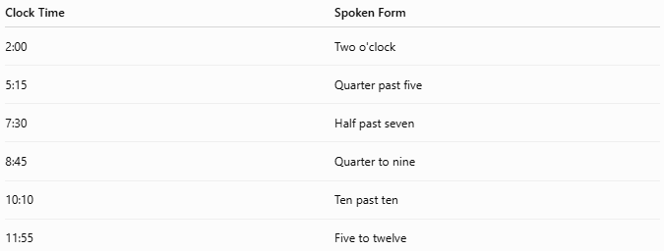
Clock Time | Spoken Form
2:00 | Two o'clock
5:15 | Quarter past five
7:30 | Half past seven
8:45 | Quarter to nine
10:10 | Ten past ten
11:55 | Five to twelve

Relationship to Time Units
# Source: AI Source: Provided by: [Data Path: Persons Table -> ID Column: 1, Name_En Column: Motasem Essam] -> From: [ChatGPT] on [7/17/2026]
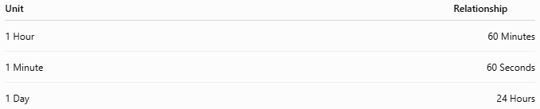
Unit | Relationship
1 Hour | 60 Minutes
1 Minute | 60 Seconds
1 Day | 24 Hours

Applications
# Source: AI Source: Provided by: [Data Path: Persons Table -> ID Column: 1, Name_En Column: Motasem Essam] -> From: [ChatGPT] on [7/17/2026]
Telling time is used in:
- Daily schedules
- School timetables
- Transportation
- Work shifts
- Medical appointments
- Sports
- Cooking
- Scientific measurements

Advantages
# Source: AI Source: Provided by: [Data Path: Persons Table -> ID Column: 1, Name_En Column: Motasem Essam] -> From: [ChatGPT] on [7/17/2026]
Knowing how to tell time helps people:
- Arrive on time.
- Plan daily activities.
- Understand schedules.
- Coordinate events.
- Communicate accurately.

Common Mistakes
# Source: AI Source: Provided by: [Data Path: Persons Table -> ID Column: 1, Name_En Column: Motasem Essam] -> From: [ChatGPT] on [7/17/2026]
- Confusing the hour hand with the minute hand.
- Forgetting that each number on an analog clock represents 5 minutes.
- Misreading AM and PM.
- Confusing 12-hour and 24-hour time formats.

Interesting Facts
# Source: AI Source: Provided by: [Data Path: Persons Table -> ID Column: 1, Name_En Column: Motasem Essam] -> From: [ChatGPT] on [7/17/2026]
- The minute hand moves 12 times faster than the hour hand.
- The second hand completes one full circle every minute.
- Most countries use both 12-hour and 24-hour formats, but transportation, military, and aviation commonly use the 24-hour format.

Key Points
# Source: AI Source: Provided by: [Data Path: Persons Table -> ID Column: 1, Name_En Column: Motasem Essam] -> From: [ChatGPT] on [7/17/2026]
- Telling time means reading clocks or watches.
- Analog clocks use:
  - Hour hand
  - Minute hand
  - Second hand
- Digital clocks display time numerically.
- Time can be expressed using:
  - 12-hour format (AM/PM)
  - 24-hour format
- Common expressions include:
  - O'clock
  - Quarter past
  - Half past
  - Quarter to

Conclusion
# Source: AI Source: Provided by: [Data Path: Persons Table -> ID Column: 1, Name_En Column: Motasem Essam] -> From: [ChatGPT] on [7/17/2026]
Telling Time is the ability to read and interpret clocks to determine the current hour, minute, and sometimes seconds. Whether using an analog or digital clock, this skill is essential for organizing daily life, following schedules, and communicating precise times. Understanding both 12-hour and 24-hour formats, along with common expressions such as quarter past and half past, provides a complete foundation for accurate and effective timekeeping.

